

**Faculty of engineering - Shoubra**

**Benha University**

**Research Project**

in fulfillment of the requirements of

|  |  |
| --- | --- |
| **Department** | **Engineering Mathematics and Physics** |
| **Division** | **-----------------** |
| **Academic Year** | **2019-2020 Preparatory** |
| **Course name** | **Computer** |
| **Course code** | **ECE001** |

**Title: -**

**…**Programing languages **…**

By:

|  |  |  |  |
| --- | --- | --- | --- |
|  | Name | Edu mail | B.N |
| 1 | يوسف عصام شعبان محمد ناصف | Youssif196195@feng.bu.edu.eg | 1063 |

**Approved by:**

|  |  |
| --- | --- |
| Examiners committee | Signature |
| Dr. Ahmed Bayoumi |  |
| Dr. Shady El mashad |  |
| Dr. Abd El hamid Attaby |  |

**Application brief:**

**Talking about programing language is very important for every software engineer so I was talking about this topic so diffentian between languages, usage and the benefit of every one is really essential for us. So I discussed a lot between most know and most popular companies and their technology they support in their applications they mad and made statistics between of them in last four years.**

**Github link:** <https://github.com/Jonasef/ECE0001>

**Source code:**

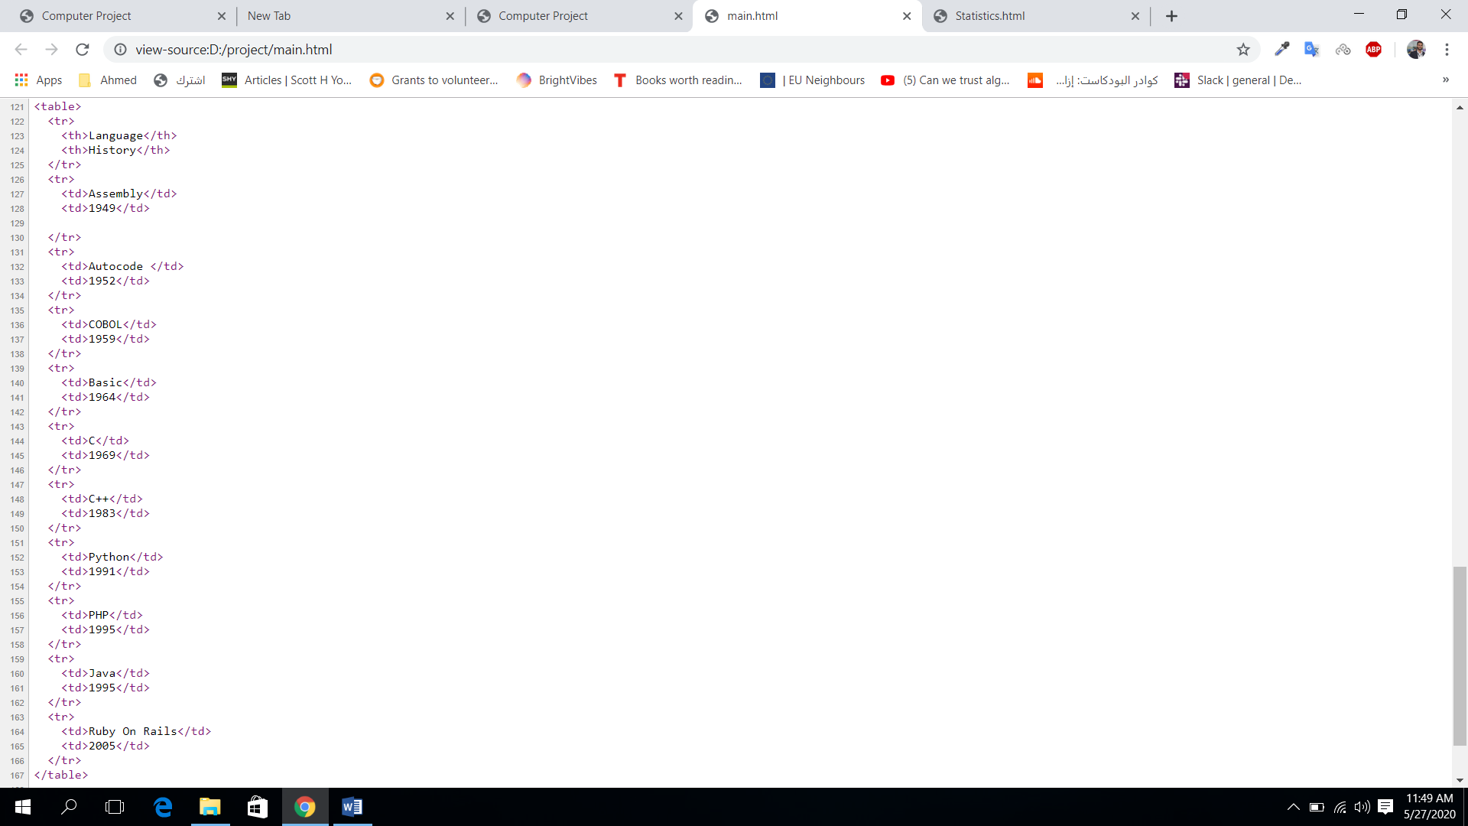

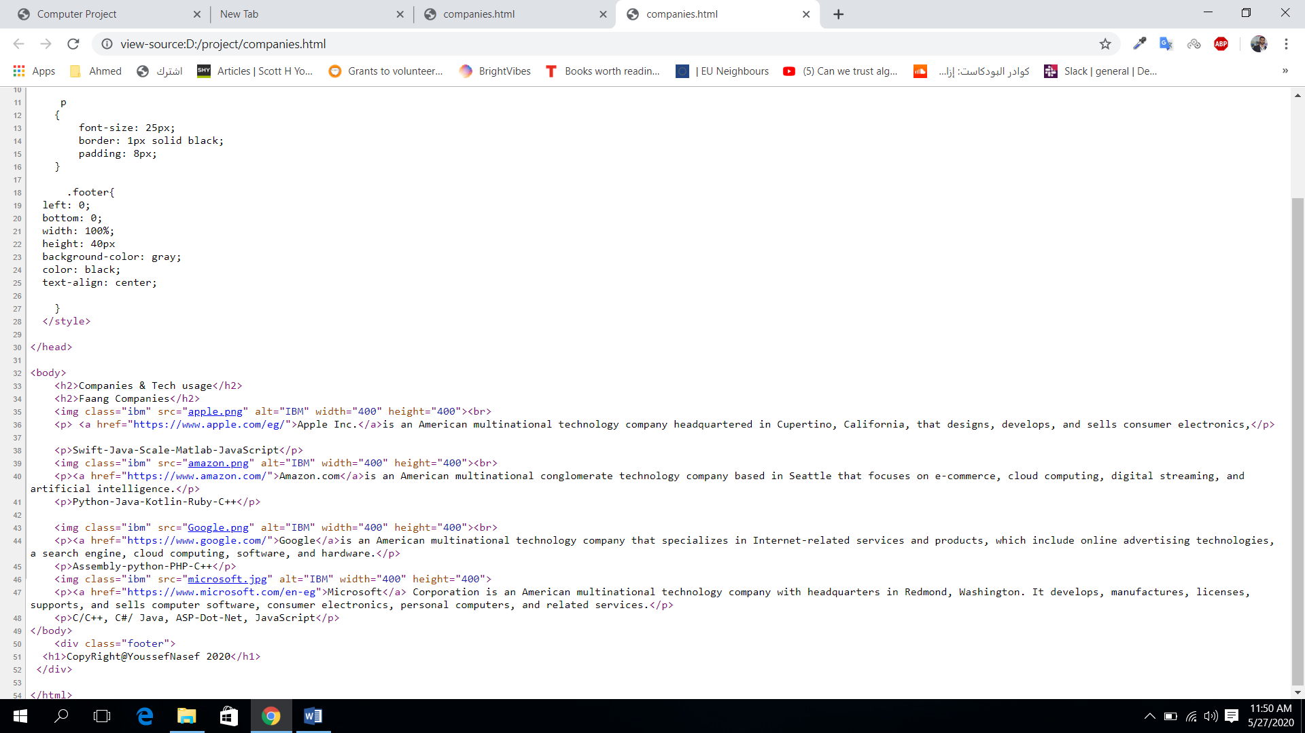

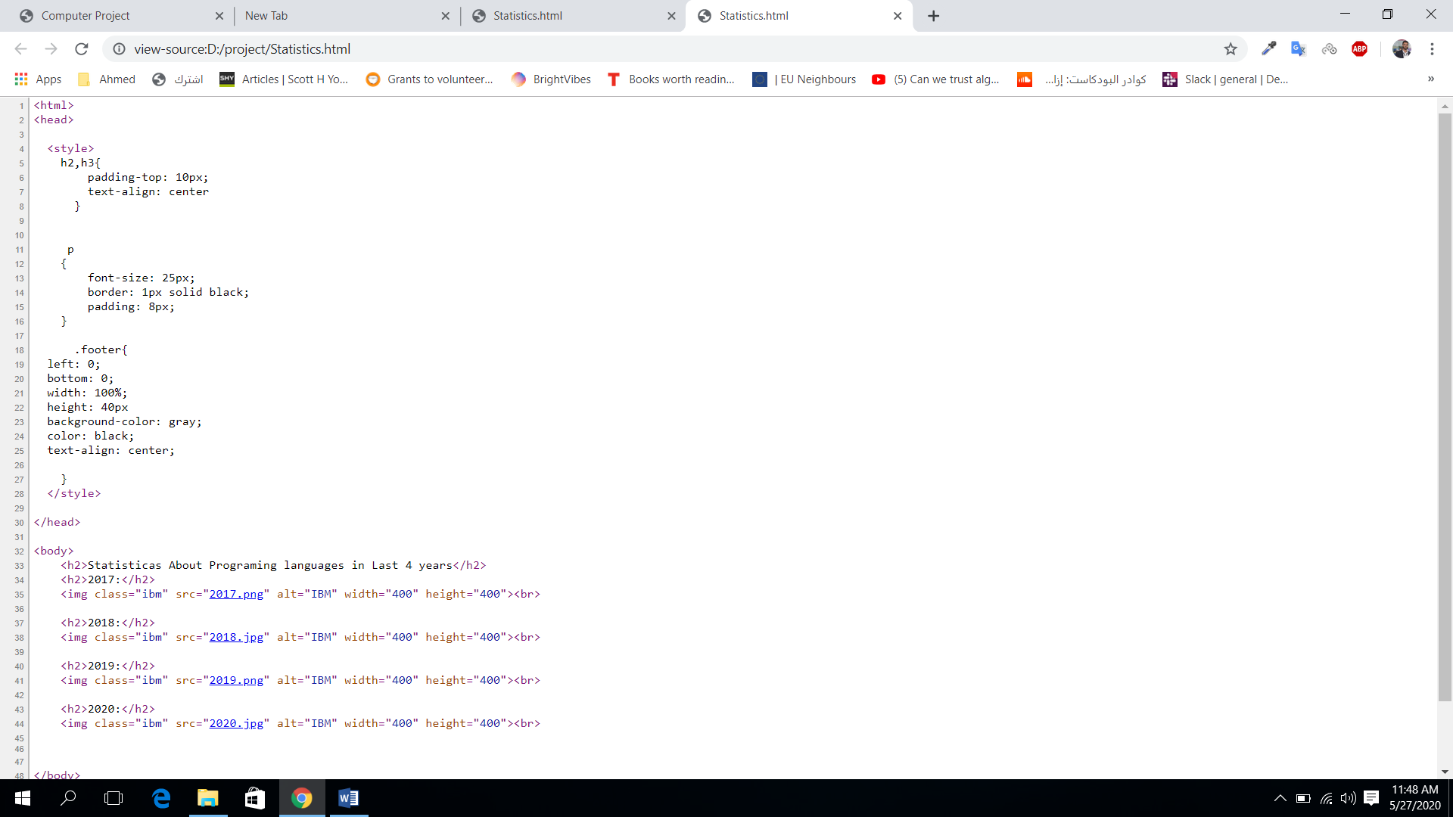

**Screenshots:**

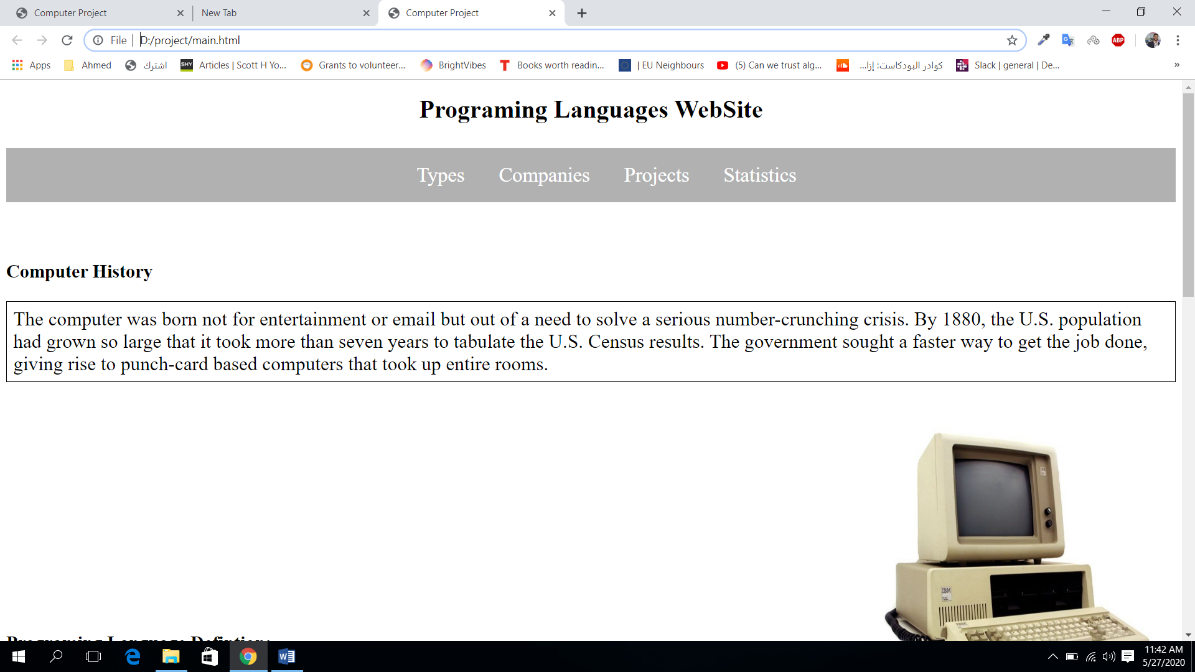

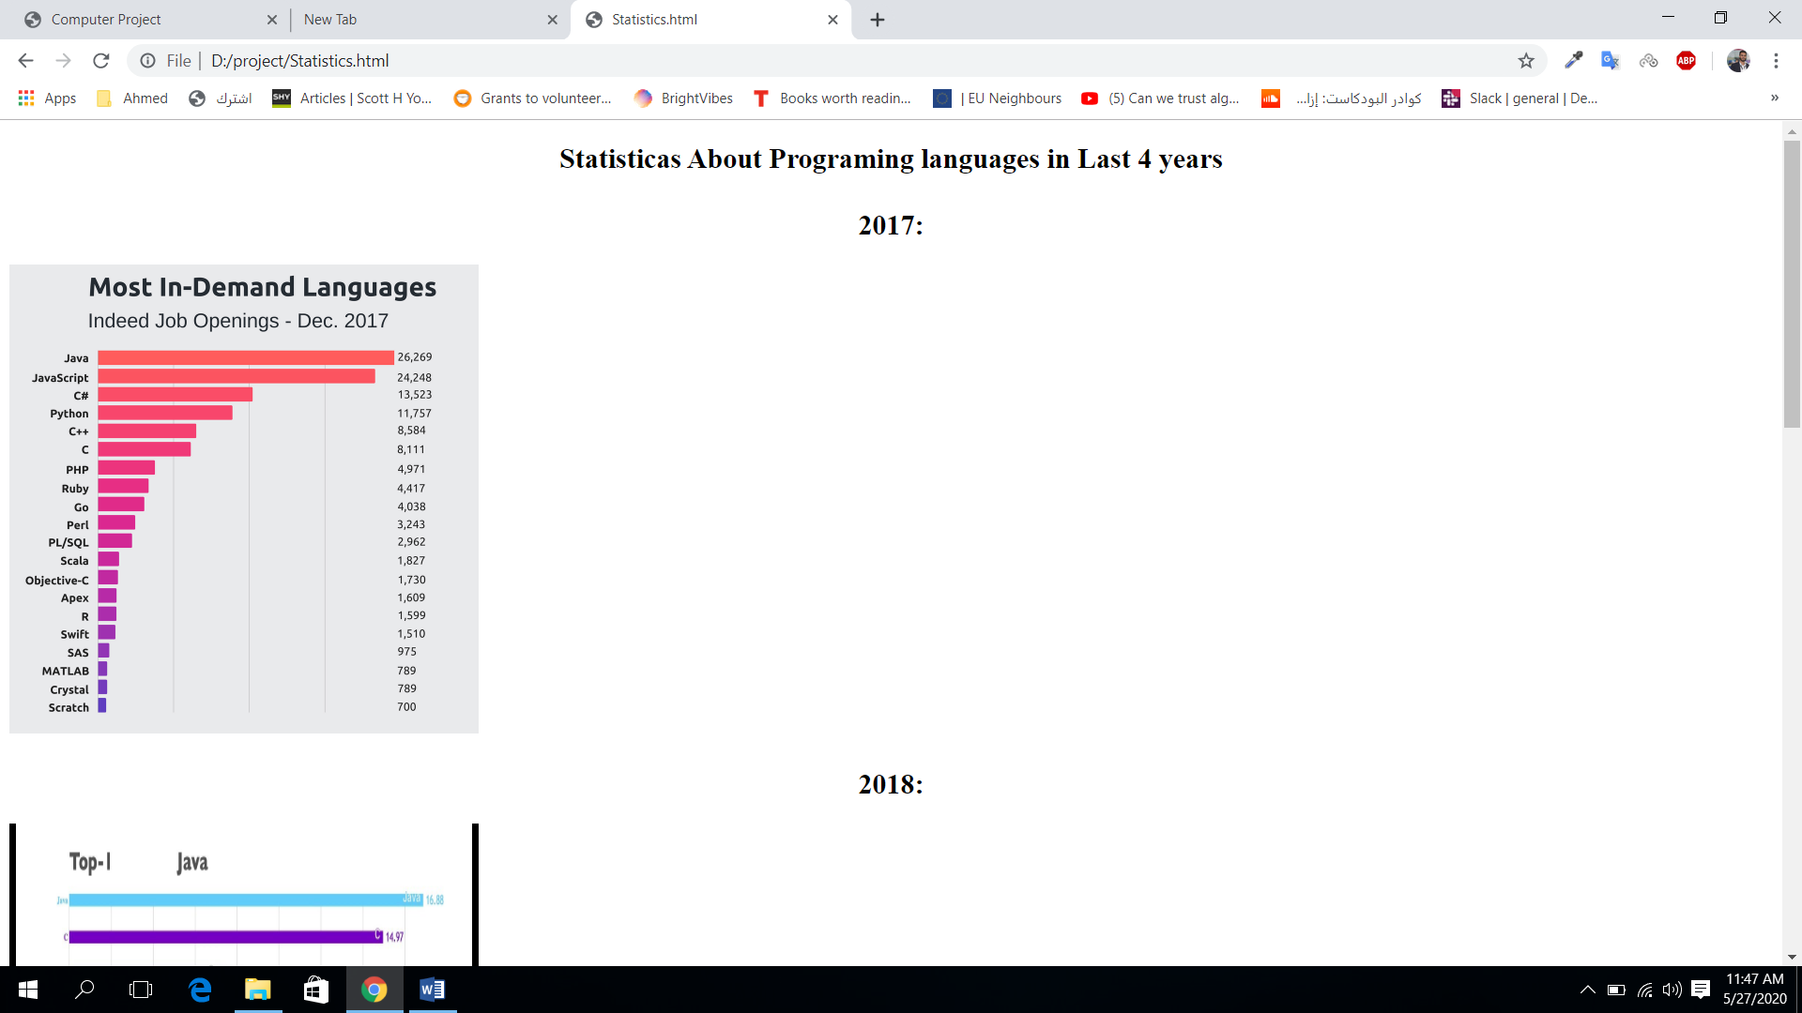

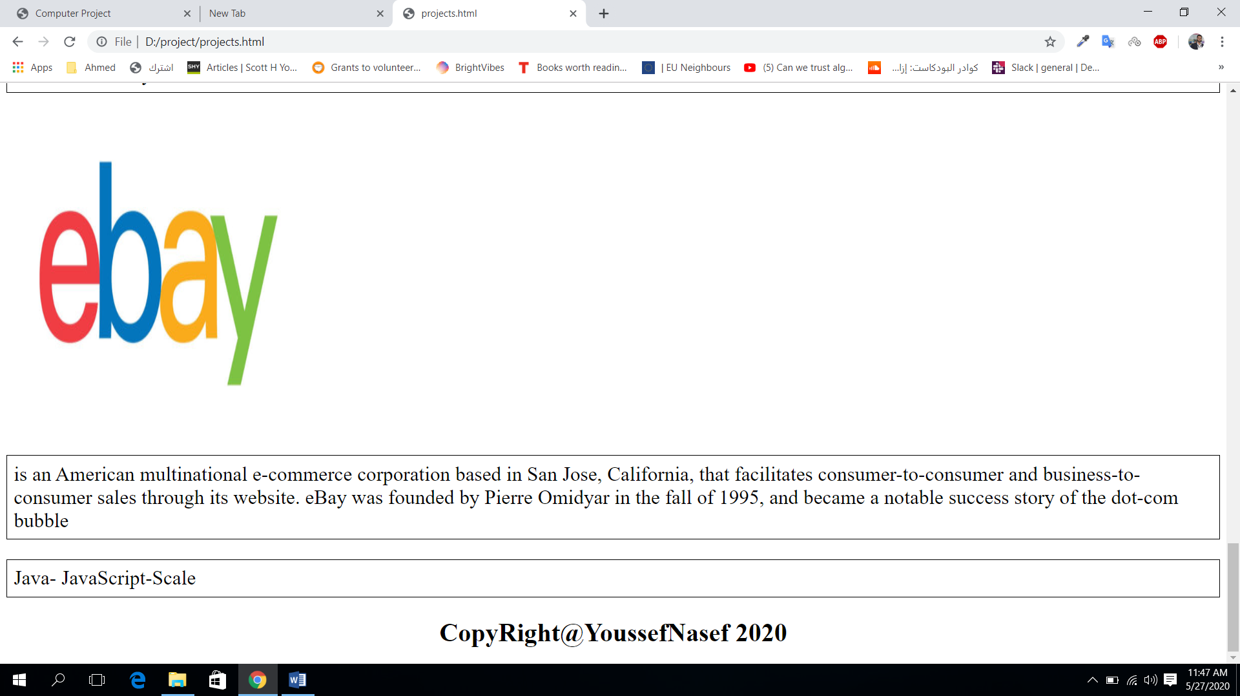

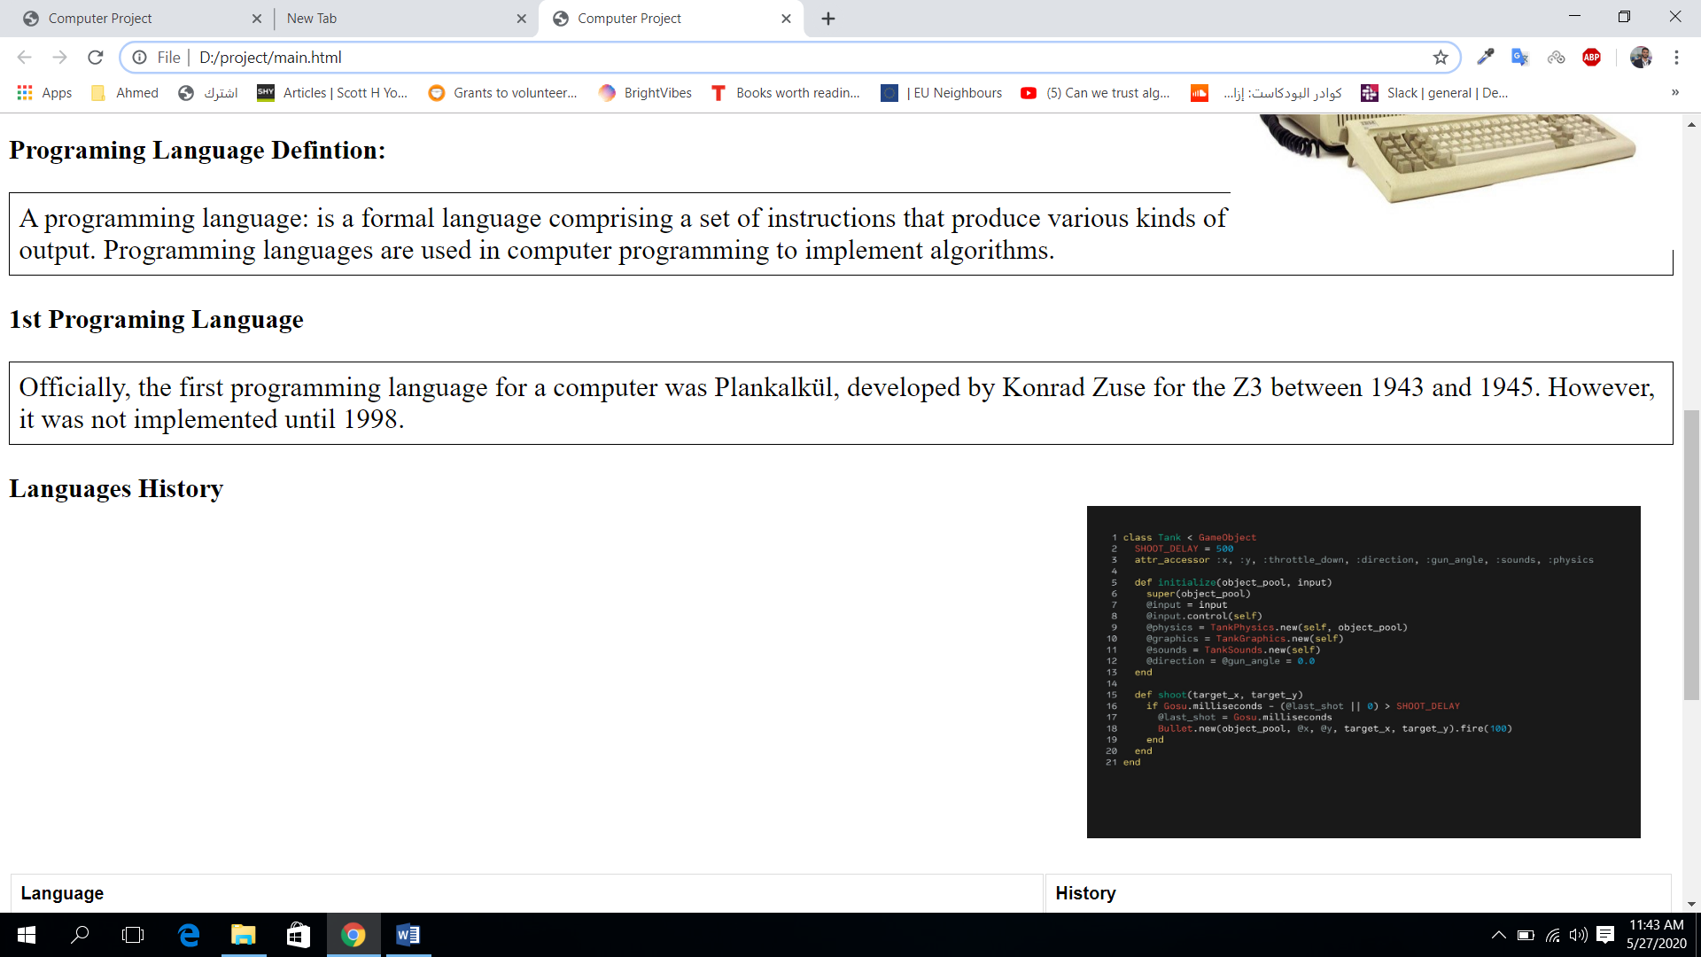

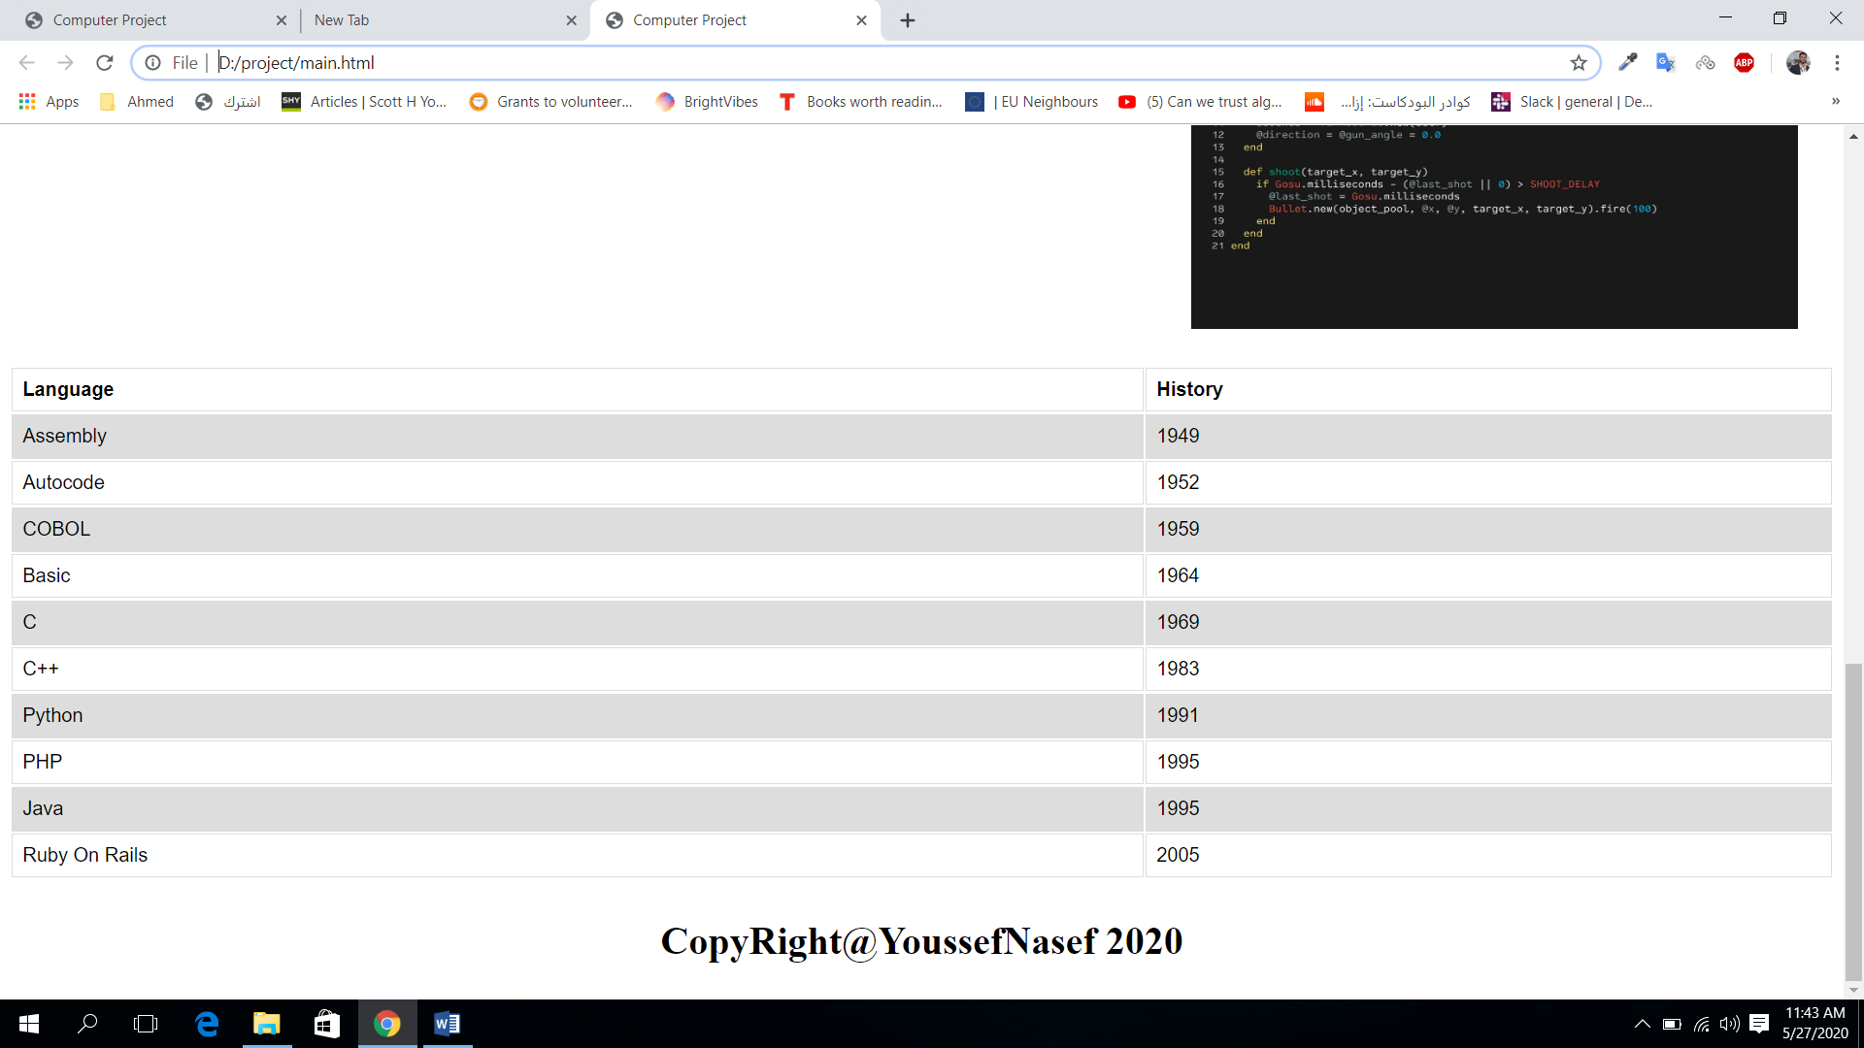

**References:**

**https://www.computerhope.com/issues/ch001621.htm**

**https://www.computerhistory.org/timeline/computers/#169ebbe2ad45559efbc6eb35720105c3**

**https://www.learneroo.com/modules/12/nodes/94**